select locno,locname,facname

from location inner join facility on location.facno=facility.facno

where facname='Basketball arena'

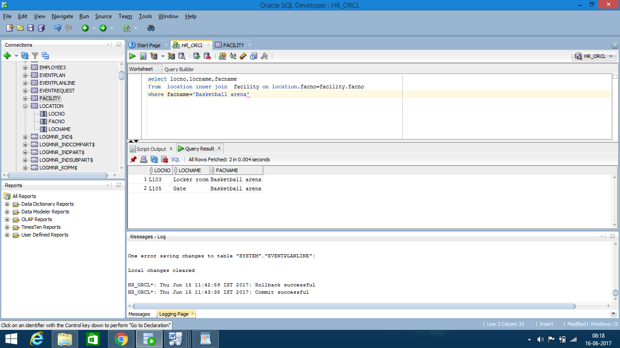

DROP TABLE Customer;

DROP TABLE Employee;

DROP TABLE Product;

DROP TABLE OrderTbl;

DROP TABLE OrdLine;

-------------------- Customer --------------------------------

CREATE TABLE Customer

( CustNo CHAR(8),

CustFirstName VARCHAR2(20) CONSTRAINT CustFirstNameRequired NOT NULL,

CustLastName VARCHAR2(30) CONSTRAINT CustLastNameRequired NOT NULL,

CustStreet VARCHAR2(50),

CustCity VARCHAR2(30),

CustState CHAR(2),

CustZip CHAR(10),

CustBal DECIMAL(12,2) DEFAULT 0,

CONSTRAINT PKCustomer PRIMARY KEY (CustNo) );

-------------------- Employee --------------------------------

CREATE TABLE Employee

( EmpNo CHAR(8),

EmpFirstName VARCHAR2(20) CONSTRAINT EmpFirstNameRequired NOT NULL,

EmpLastName VARCHAR2(30) CONSTRAINT EmpLastNameRequired NOT NULL,

EmpPhone CHAR(15),

EmpEMail VARCHAR(50) CONSTRAINT EmpEMailRequired NOT NULL,

SupEmpNo CHAR(8),

EmpCommRate DECIMAL(3,3),

CONSTRAINT PKEmployee PRIMARY KEY (EmpNo),

CONSTRAINT UniqueEMail UNIQUE(EmpEMail),

CONSTRAINT FKSupEmpNo FOREIGN KEY (SupEmpNo) REFERENCES Employee );

-------------------- Product --------------------------------

CREATE TABLE Product

( ProdNo CHAR(8),

ProdName VARCHAR2(50) CONSTRAINT ProdNameRequired NOT NULL,

ProdMfg VARCHAR2(20) CONSTRAINT ProdMfgRequired NOT NULL,

ProdQOH INTEGER,

ProdPrice DECIMAL(12,2),

ProdNextShipDate DATE,

CONSTRAINT PKProduct PRIMARY KEY (ProdNo) );

-------------------- OrderTbl --------------------------------

CREATE TABLE OrderTbl

( OrdNo CHAR(8),

OrdDate DATE CONSTRAINT OrdDateRequired NOT NULL,

CustNo CHAR(8) CONSTRAINT CustNoRequired NOT NULL,

EmpNo CHAR(8),

OrdName VARCHAR2(50),

OrdStreet VARCHAR2(50),

OrdCity VARCHAR2(30),

OrdState CHAR(2),

OrdZip CHAR(10),

CONSTRAINT PKOrderTbl PRIMARY KEY (OrdNo),

CONSTRAINT FKCustNo FOREIGN KEY (CustNo) REFERENCES Customer,

CONSTRAINT FKEmpNo FOREIGN KEY (EmpNo) REFERENCES Employee );

-------------------- OrdLine --------------------------------

CREATE TABLE OrdLine

( OrdNo CHAR(8),

ProdNo CHAR(8),

Qty INTEGER DEFAULT 1,

CONSTRAINT PKOrdLine PRIMARY KEY (OrdNo, ProdNo),

CONSTRAINT FKOrdNo FOREIGN KEY (OrdNo) REFERENCES OrderTbl

ON DELETE CASCADE,

CONSTRAINT FKProdNo FOREIGN KEY (ProdNo) REFERENCES Product );

9999999999999999999999999999999999999999999999999999999999999999

DROP TABLE Customer;

DROP TABLE Employee;

DROP TABLE Product;

DROP TABLE OrderTbl;

DROP TABLE OrdLine;

-------------------- Customer --------------------------------

CREATE TABLE Customer

( CustNo CHAR(8),

CustFirstName VARCHAR(20) NOT NULL,

CustLastName VARCHAR(30) NOT NULL,

CustStreet VARCHAR(50),

CustCity VARCHAR(30),

CustState CHAR(2),

CustZip CHAR(10),

CustBal DECIMAL(12,2) DEFAULT 0,

CONSTRAINT PKCustomer PRIMARY KEY (CustNo) );

-------------------- Employee --------------------------------

CREATE TABLE Employee

( EmpNo CHAR(8),

EmpFirstName VARCHAR(20) NOT NULL,

EmpLastName VARCHAR(30) NOT NULL,

EmpPhone CHAR(15),

EmpEMail VARCHAR(50) NOT NULL,

SupEmpNo CHAR(8),

EmpCommRate DECIMAL(3,3),

CONSTRAINT PKEmployee PRIMARY KEY (EmpNo),

CONSTRAINT UniqueEMail UNIQUE (EmpEMail),

CONSTRAINT FKSupEmpNo FOREIGN KEY (SupEmpNo) REFERENCES Employee (EmpNo));

-------------------- Product --------------------------------

CREATE TABLE Product

( ProdNo CHAR(8),

ProdName VARCHAR(50) NOT NULL,

ProdMfg VARCHAR(20) NOT NULL,

ProdQOH INTEGER,

ProdPrice DECIMAL(12,2),

ProdNextShipDate DATE,

CONSTRAINT PKProduct PRIMARY KEY (ProdNo) );

-------------------- OrderTbl --------------------------------

CREATE TABLE OrderTbl

( OrdNo CHAR(8),

OrdDate DATE NOT NULL,

CustNo CHAR(8) NOT NULL,

EmpNo CHAR(8),

OrdName VARCHAR(50),

OrdStreet VARCHAR(50),

OrdCity VARCHAR(30),

OrdState CHAR(2),

OrdZip CHAR(10),

CONSTRAINT PKOrderTbl PRIMARY KEY (OrdNo),

CONSTRAINT FKCustNo FOREIGN KEY (CustNo) REFERENCES Customer (CustNo),

CONSTRAINT FKEmpNo FOREIGN KEY (EmpNo) REFERENCES Employee (EmpNo) );

-------------------- OrdLine --------------------------------

CREATE TABLE OrdLine

( OrdNo CHAR(8),

ProdNo CHAR(8),

Qty INTEGER DEFAULT 1,

CONSTRAINT PKOrdLine PRIMARY KEY (OrdNo, ProdNo),

CONSTRAINT FKOrdNo FOREIGN KEY (OrdNo) REFERENCES OrderTbl (OrdNo)

ON DELETE CASCADE,

CONSTRAINT FKProdNo FOREIGN KEY (ProdNo) REFERENCES Product (ProdNo) );